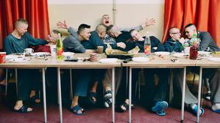
Polish Boys Reform School dinner for young thieves, rapists and murderers by Z. Krajewska

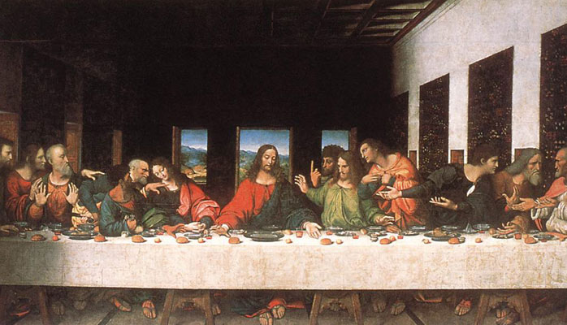
J.C. by Da Vinci

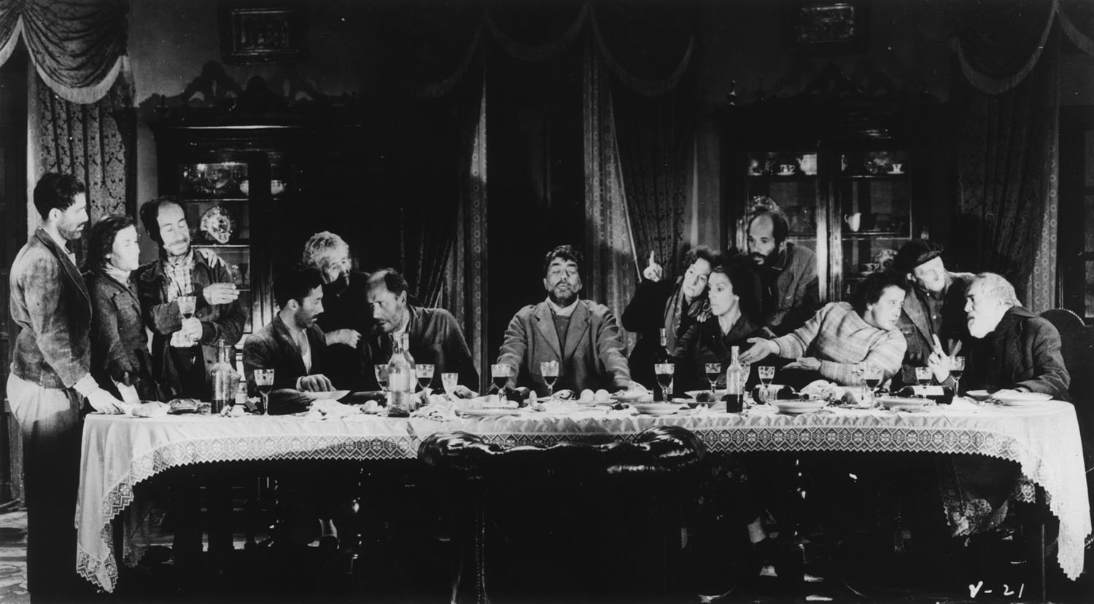
Viridiana’s scoundrels by Buñuel

